An
Major Project Report on

ONLINE VOTING SYSTEM USING BLOCKCHAIN
Submitted in partial fulfillment of the requirements for the award of degree

BACHELOR OF TECHNOLOGY

IN

COMPUTER SCIENCE AND ENGINEERING

Submitted By

S. PRIYANKA 217Z1A05G7
MD. ALTHAF PASHA 227Z5A0514
V.VIJAY 227Z5A0520

Under the Guidance of

Dr . K. SRINIVAS BABU

Professor



SCHOOL OF ENGINEERING
Department of Computer Science and Engineering

NALLA NARASIMHA REDDY EDUCATION SOCIETY’S GROUP OF INSTITUTION
(AN AUTONOMOUS INSTITUTION)
Approved by AICTE, New Delhi, Chowdariguda (V) Korremula ‘x’ Roads, Via Narapally, Ghatkesar (Mandal)Medchal (Dist), Telangana-500088
2024-2025



SCHOOL OF ENGINEERING

DEPARTMENT OF COMPUTER SCIENCE AND ENGINEERING

CERTIFICATE

This is to certify that the project report titled “ONLINE VOTING SYSTEM USING BLOCKCHAIN” is being submitted by S. PRIYANKA (217Z1A05G7) and MD. ALTHAF PASHA (227Z5A0514), V. VIJAY (227Z5A0520) in Partial fulfilment for the award of Bachelor of technology in Computer Science & Engineering is a record bonfire work carried out by them. The results embodied in this report have not been submitted to any other University for the award of any degree.

Internal Guide | Head of the Department
(Dr. K. Srinivas Babu) | (Dr. K. Rameshwaraiah)

Submitted for Viva voce Examination held on ……………………………….

External Examiner

DECLARATION

We S.Priyanka, MD.Althaf Pasha and V.Vijay, the students of Bachelor of Technology in Computer Science and Engineering, Nalla Narasimha Reddy Education Society’s Group Of Institutions, Hyderabad, Telangana, hereby declare that the work presented in this project work entitled Online Voting System Using Blockchain is the outcome of our own bonafide work and is correct to the best of our knowledge and this work has been undertakentaking care of engineering ethics. It contains no material previously published or written byanother person nor material which has been accepted for the award of any other degree or diploma of the university or other institute of higher learning.

By:

S. PRIYANKA 217Z1A05G7
MD ALTHAF PASHA 227Z5A0514
V. VIJAY 227Z5A0520

Date: Signature:

ACKNOWLEDGEMENT

We express our sincere gratitude to our guide Dr. K. Srinivas Babu, Assistant Professor, in Computer Science and Engineering Department, NNRESGI, who motivated throughout the period of the project and also for his valuable and intellectual suggestions apart from hisadequate guidance, constant encouragement right throughout our work.
We would like to express our profound gratitude to our mini project in-charge Mrs.Ch. Ramya, Assistant Professor, NNRESGI, for her support and guidance in completing our project and for giving us this opportunity to present the project work.

We profoundly express our sincere thanks to Dr. K. Rameshwaraiah, Professor & Head, Department of Computer Science and Engineering, NNRESGI, for his cooperation and encouragement in completing the project successfully.

We wish to express our sincere thanks to Dr. G. Janardhana Raju, Dean School ofEngineering, NNRESGI, for providing the facilities for completion of the project.

We wish to express our sincere thanks to Dr. C. V. Krishna Reddy, Director NNRESGI for providing the facilities for completion of the project.

Finally, we would like to thank Project Co-Ordinator, Project Review Committee (PRC) members, all the faculty members and supporting staff, Department of Computer Science and Engineering, NNRESGI for extending their help in all circumstances.

By:

S. PRIYANKA 217Z1A05G7
MD ALTHAF PASHA 227Z5A0514
V. VIJAY 227Z5A0520

ABSTRACT

The Paper ballots are mostly utilized across the world. Only in the last ten years are electronic voting systems popular and unresolved. E-voting schemes pose mainly safety, credibility, openness, reliability and functionality challenges. Blockchain can offer a response to all of the difficulties above and also offer certain benefits such as immutability and decentralization. The key challenges with blockchain technology for e-voting include focusing on just one subject or the absence of testing and comparison. We describe in this paper a blockchain-based e-voting infrastructure that may be utilized for any voting purpose. The blockchain is fully used and all processes can be processed. After the vote starts, the platform is entirely independent without any chance of affecting the voting process and is decentralized. The data are completely transparent, but homomorphic encryption ensures the identity of the voters. In three distinct blockchains, we tested and compared our solution. The results reveal that public as well as private blockchains are available at a little velocity difference. The primary innovation of our approach is the complete decentralization of management of the e- voting platform via blockchains, transparency and, owing to homomorphic encryption of voters, security and privacy.

Keywords: Blockchain, E-Voting, Decentralization, Immutability

TABLE OF CONTENTS

 | Page No.
Abstract
List Of Figures | i
List Of Tables | ii
1. INTRODUCTION | 1
1.1 Motivation | 1
1.2 Problem Statement | 1
1.3 Purpose | 1
1.4 Scope | 1
1.5 Project Objective | 2
1.6 Limitations | 2
2. LITERATURE SURVEY | 4
2.1 Introduction | 4
2.2 Existing System | 4
2.3 Proposed System | 4
3. SYSTEM ANALYSIS | 5
3.1 Functional Requirements | 5
3.2 Non Functional Requirements | 6
3.3 Interface Requirements | 7
4. SYSTEM DESIGN | 9
4.1 Uml Diagrams | 9
4.2 Data Flow Diagram | 12
4.3 Use case Diagram | 13
4.4 Class Diagram | 14
4.5 Sequence Diagram | 15
4.6 Activity Diagram | 16
4.7 Modules | 17

5. IMPLEMENTATION&RESULTS | 18
5.1 Method of Implementation | 18
5.2 Explanation of Key Functions | 19
5.3 Output Screens | 27
6. SYSTEM TESTING | 33
6.1 Introduction | 33
6.2 Various Test Cases Scenarios | 34
7. CONCLUSION | 37
7.1 Project Conclusion | 37
7.2 Future Enhancements | 37
8. REFERENCES | 38
8.1 Journals | 38
8.2 Web Links | 38
8.3 Text Books | 38

LIST OF FIGURES

Figure No. | Name Of The Figure | Page No.
4.1 | DFD | 12
4.2 | Use Case Diagram | 13
4.3 | Class Diagram | 14
4.4 | Sequence diagram | 15
4.5 | Activity diagram | 16
5.1 | Home page 1 | 27
5.2 | Home page 2 | 27
5.3 | Candidate registration 1 | 28
5.4 | Candidate registration 2 | 28
5.5 | First candidate registration | 29
5.6 | Second candidate registration | 29
5.7 | Candidate list in home page | 30
5.8 | Voter registration | 30
5.9 | Voter list in home page | 31
5.10 | Voter casted | 31
5.11 | Votes tampering | 32

LIST OF TABLES

Table No. | Name Of The Table | Page No.
6.1 | Test Cases | 34-36

- INTRODUCTION

MOTIVATION

The Our main motivation in this project is to provide a secure voting environment and show that a reliable e-voting scheme is possible using blockchain. It’s important for us since elections can easily be corrupted or manipulated especially in small towns, and even in bigger cities located in corrupt countries. Plus, large-scale traditional elections are very expensive in the long term, especially if there are hundreds of geographically distributed vote centers and millions of voters

Problem Statement

Whether talking about traditional paper-based voting, voting via digital voting machines, or an online voting system, several conditions need to be satisfied: Eligibility: Only legitimate voters should be able to take part in voting. Unreusability: Each voter can vote only once. Privacy: No one except the voter can obtain information about the voter’s choice. Fairness: No one can obtain intermediate voting results

PURPOSE
The people who vote could question the fairness and confidentiality of the voting process. Police and security services have access to network traffic’s variety and processing capacity to examine polling data for possible alterations. System attacks are still likely in all previous schemes, even though security is strengthened. Some enhanced security schemes or processes must also ensure that voting or measuring procedures are reliable and the above listed issues are avoided.

SCOPE
Making the system more secure. Enhancing the Graphical User Interface (GUI) of the application. Local languages can be included which will play a vital role for people living in rural areas as well as uneducated people.

PROJECT OBJECTIVE
A blockchain e-voting platform can be utilized for any type of vote is the principal purpose of our project. The blockchain is fully used and all processes can be processed. After the vote starts, the platform is completely autonomous and decentralized without having the opportunity to influence the voting process.

LIMITATIONS OF PROJECT

Security Concerns

Hacking and Cyberattacks: E-voting systems are vulnerable to hacking, malware, and other which could compromise the integrity of the vote.
Data Privacy: Protecting the anonymity of voters while ensuring transparency is challenging. A breach could lead to exposure of voter identity and choices.
Voter Fraud: The potential for fraudulent votes or manipulation by insiders (e.g., system administrators) is a concern.

Technical Issues

System Failures: Software glitches, hardware malfunctions, or server failures could disrupt the voting process.
Digital Divide: Not everyone has equal access to the internet or the required technology, potentially disenfranchising some voters.
Authentication: Verifying voter identity securely without compromising privacy can be difficult.

Transparency and Trust

Lack of Transparency: E-voting systems are often seen as "black boxes" since the public may not fully understand how they work, which could lead to mistrust.

Accessibility

Digital Literacy: Some voters may struggle to use electronic voting systems due to a lack of technical knowledge, limiting their ability to participate.

Disability Access: While e-voting systems can improve accessibility for some disabled voters, they may present new barriers for others, depending on the design.
Initial Setup and Maintenance: E-voting systems require significant investment in technology infrastructure, security protocols and regular maintenance, making them.

LITERATURE SURVEY

INTRODUCTION
M. Pawlak, J. Guziur, and A. Poniszewska-Mara nda, inLearning Notes on the Data Engineering and Communications Technologies, pp. 233–244, Springer, CHAM, 2019, "Voting Process with Blockchain Technology: Auditable Blockhain Voting System." Electronic voting is based on different methods and approaches worldwide. Each has various advantages and problems. The lack of audit capability and system verification procedures is one of the most essential and widespread difficulties. This issue can be resolved by Blockchain technology, which has recently attracted a lot of attention. This work proposes an auditable Blockchain Voting System, which explains electronic voting processes and components of an audit and verification-capable supervised Internet voting system. The ABVS uses blockchain technology and the paper audit trail validated by voters to achieve this. N. Kshetri and J. Voas, IEEE Software, Vol. 35, pp. 95-99, Jul 2018: "Blockchain-Enabled E Voting." E-voting (BEV) that could prevent voting fraud by increasing access to voters could be blockchain-enabled. Eligible voters vote on a computer or smartphone anonymously. BEV uses encrypted key .

EXISTING SYSTEM
The Blockchain is a distributed record database, often called a ledger. The key assumption is that the records that are previously written in blocks are immutable. Advanced encryption is utilised to ensure that blocks are chained and data integrity is guaranteed. The type of network connectivity is another feature. Clientclient technique communicates with network nodes. No third party is able to communicate between customers and hence there is no need for trust. The real identity of the network participant is unknown . We will explore various existing solutions for blockchain- based evoting systems

PROPOSED SYSTEM
The suggested blockchain voting system takes account of all voting needs and is typically suitable for any election, e.g. president, student parliament, etc. The approach enables more round elections and uses a public blockchain preferable.

SYSTEM ANALYSIS

FUNCTIONAL REQUIREMENTS

Data Voter Registration

    - The system must allow eligible voters to register before the election using secure registration processes.
    - Voter identities must be validated and tied to unique cryptographic keys, ensuring that each voter can only register once.

Vote Casting

    - Voters must be able to securely cast their vote through an easy-to-use interface, with options for voting via desktop or mobile devices.
    - The system must prevent duplicate voting by allowing each user to cast only one vote.
    - Voting should be anonymous, ensuring that voter identities are not linked to their votes.

Vote Encryption

    - Votes must be encrypted before being recorded on the blockchain to ensure that they remain private.
    - The system should support end-to-end encryption of votes during transmission and storage.

Blockchain Recording

    - Each vote must be recorded immutably on the blockchain, ensuring that votes cannot be altered or deleted after they are cast.
    - The system must timestamp and hash each vote entry to ensure integrity.

Vote Verification

    - The system must allow voters to verify that their vote has been correctly recorded on the blockchain without compromising vote secrecy.

    - Voters should be able to receive a receipt or token that confirms their vote is counted.

Counting and Results Generation

    - The system must count votes automatically and securely once voting ends.

    - The system should allow real-time tallying and reporting, while ensuring accuracy.

NON-FUNCTIONAL REQUIREMENTS

Performance

    - The The system must be scalable to handle large numbers of users and votes, whether for local
    - The system must protect against hacking, data breaches, and tampering of votes or the blockchain.
    - Encryption of sensitive data such as voter credentials and vote content is essential.

    - The blockchain must be resistant to Sybil attacks, ensuring that bad actors cannot compromise the network by creating multiple identities.

Privacy and Anonymity

    - The system must ensure complete voter anonymity, meaning that it should not be possible to trace a vote back to a voter after it is cast.
    - The voting system should comply with privacy regulations, ensuring sensitive voter data is not exposed.

Performance and Efficiency

    - The voting system should be efficient, processing votes and verifying their inclusion on the blockchain quickly to prevent delays.
    - System response times must be acceptable, ensuring that users can cast their votes without experiencing lags or downtime.

Reliability and Availability

    - The system must be highly reliable and available during the voting period to avoid downtime that might prevent users from voting.

    - The system should have fault-tolerance mechanisms in place, allowing it to recover from potential network failures or system crashes.

Transparency

    - The blockchain's distributed ledger should be publicly accessible to allow for transparent auditing while still preserving voter privacy.
    - Any observer should be able to verify the number of votes cast and the correctness of the results without having access to sensitive data.

Maintainability

    - The system should be easy to update and maintain, particularly for bug fixes and security patches, without affecting ongoing elections.
    - It should allow for future improvements in voting processes without major re- architecture.

INTERFACE REQUIREMENTS
Login/Authentication Page:
    - Support for secure login via multiple methods (e.g., government-issued digital IDs, biometric authentication, or cryptographic key-based authentication).
    - Two-factor authentication (2FA) or multi-factor authentication (MFA) for additional security.
Voting Dashboard:
    - Simple, user-friendly design with clear instructions on how to cast a vote.
    - Voter should be able to see the list of available candidates or choices clearly.
    - Confirmation page showing the selected vote, with the ability to review before final submission.
Hardware Requirements
    - System : MINIMUM i5.
    - Hard Disk : 40 GB.
    - Ram : 4 GB.
Software Requirements:
    - Operating system : windows 11
    - Coding language : Html ,Javascript , python, css

Performance Requirements
The It works fine with moderate internet speed. The connection is secured and user details are stored in a secured manner. The switch from one screen to another is quick and smooth. The inputs from users are taken correctly and response is recorded quickly.

SYSTEM DESIGN

UML DIAGRAMS
UML stands for Unified Modeling Language. UML is a standardized general- purpose modeling language in the field of object-oriented software engineering. The standard is managed, and was created by, the Object Management Group. The goal is for UML to become a common language for creating models of object oriented computer software. In its current form UML is comprised of two major components: a Meta-model and a notation. In the future, some form of method or process may also be added to; or associated with, UML.
The Unified Modeling Language is a standard language for specifying, Visualization, Constructing and documenting the artifacts of software system, as well as for business modeling and other non-software systems. The UML represents a collection of best engineering practices that have proven successful in the modeling of large and complex systems.
The UML is a very important part of developing objects oriented software and the software development process. The UML uses mostly graphical notations to express the design of software projects.
Actor: An actor is a model element that interacts with a system


Use Case: A use case describes a function that a system performs to achieve the user’s goal


Use case system: A system of a use case defines and represents boundaries of a business, software system, physical system or device, subsystem,


Associations: A line between actors and use cases. It describes which actors are associated with which use cases

Class: A class represents an object or a set of objects that share a common structure and behavior.
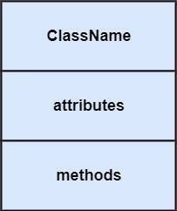
Generalization: A generalization is a relationship between a parent class and a child class. In this, the child class is inherited from the parent class.
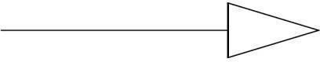

Composition: It portrays the dependency between the parent and its child


Action: An action is a named element that is the fundamental unit of an executable functionality.
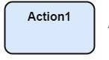
Join: Join nodes are used to support concurrent activities converging into one
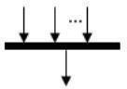

Call Message: It depicts workflow or activity over time using messages passed from element to element
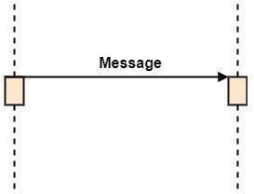

Activation: It is represented by a thin rectangle on the life line. It describes that time period in which an operation is performed by an element
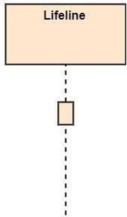
Final State: It is the stage where all the control flows and object flow end.


Data Flow Diagram
A data flow diagram (DFD) maps out the flow of information for any process or system.It uses defined symbols like rectangles, circles and arrows, plus short text labels, to show data inputs, outputs, storage points and the routes between each destination. There are 2 levels in the below diagram.

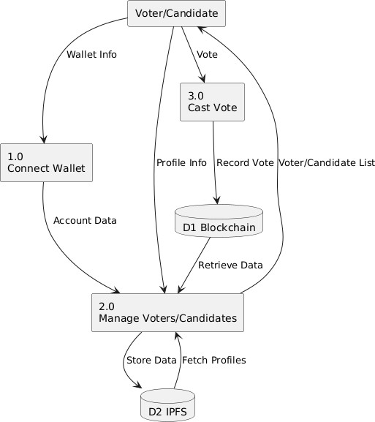

Fig :4.1 Data Flow Diagram

Use Case Diagram:
A use case diagram in the Unified Modeling Language (UML) is a type of behavioral diagram defined by and created from a Use-case analysis. Its purpose is to present a graphical overview of the functionality provided by a system in terms of actors, their goals (represented as use cases), and any dependencies between those use cases. The main purpose of a use case diagram is to show what system functions are performed for which actor. Roles of the actors in the system can be depicted.

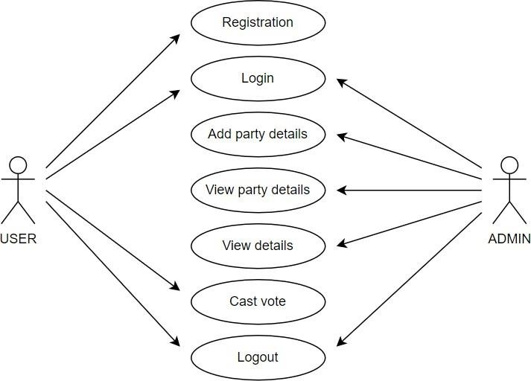

Fig :4.2 Use case Diagram

Class Diagram
software engineering, a class diagram in the Unified Modeling Language (UML) is a type of static structure diagram that describes the structure of a system by showing the system's classes, their attributes, operations (or methods), and the relationships among the classes. It explains which class contains information.

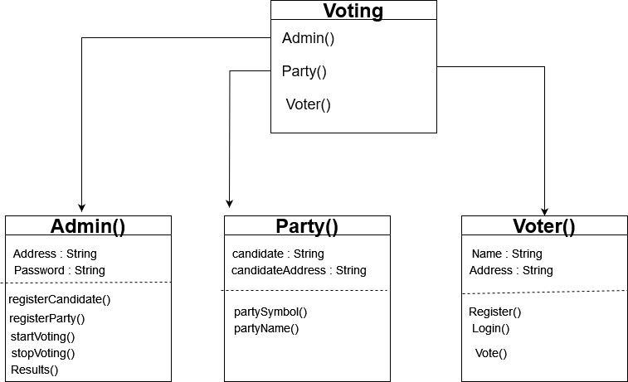

Fig :4.3 class diagram

Sequence Diagram:
A sequence diagram in Unified Modelling Language (UML) is a kind of interaction diagram that shows how processes operate with one another and in what order. It is a construct of a Message Sequence Chart. Sequence diagrams are sometimes called event diagrams, event scenarios, and timing diagrams.

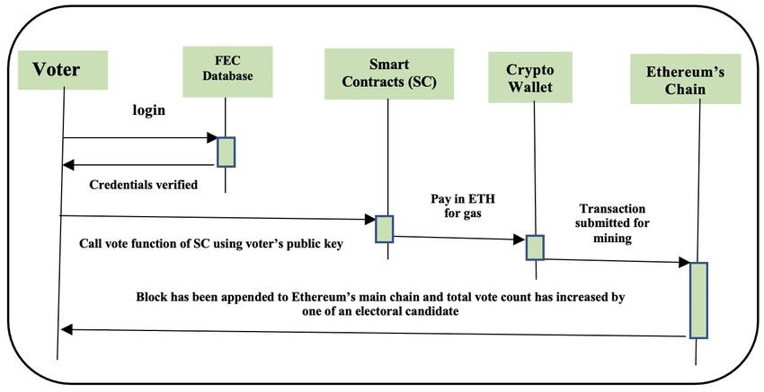

Fig :4.4 Sequence Diagram

Activity Diagram
Activity diagrams are graphical representations of workflows of stepwise activities and actions with support for choice, iteration and concurrency. In the Unified Modeling Language, activity diagrams can be used to describe the business and operational step- by-step workflows of components in a system. An activity diagram shows the overall flow of control.

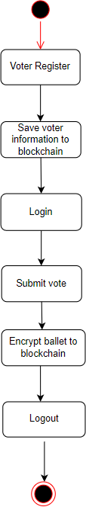

Fig :4.5 Activity Diagram

MODULES
- Voter Registration:
Allows users to register with personal details such as ID verification, biometric data, or digital IDs.
Integration with government or external databases to validate voter identity.

Authentication:

Implements multi-factor authentication (MFA) using email, SMS OTP, or biometric verification.
Ensures secure login using cryptographic methods (e.g., digital signatures).

Voter Eligibility:

Checks voter eligibility based on pre-defined criteria (e.g., citizenship, age, voter list).

Ensures that each voter can only register and vote once, using cryptographic techniques like zero-knowledge proofs.

Vote Casting Module.

Ensures that votes are private and tamper-proof using cryptographic algorithms (e.g., AES-256).

Vote Confirmation:

Provides real-time confirmation that the vote has been cast successfully and recorded on the blockchain.

IMPLEMENTATION & RESULTS

MTHEOD OF IMPLIMENTATION

Blockchain Development

    - Tools: MetaMask, Node.js, Hardhat Framework

    - Step-by-step:

    - Use MetaMask as a wallet to connect the frontend to the Ethereum network (local, testnet, or mainnet).
    - Write the code to interact with the smart contract using Web3.js or Ethers.js in Node.js. This allows users to send transactions (votes) and read data (results).
    - Example of interaction using Web183.j Design tTesting the Smart Contracts Tools: Hardhat Framework
    - Step-by-step:

    - Set up a local Ethereum network using Hardhat.

    - Test the Solidity smart contracts locally to ensure functionality (e.g., one person, one vote).
    - Write unit tests using Mocha or Chai frameworks to verify the contract logic.

    - Example of a Hardhat test script

Key Tools & Technologies:

    - HTML/CSS/JavaScript: Frontend development.

    - Solidity: Writing smart contracts for handling the voting logic.

    - Node.js (Web3.js/Ethers.js): Backend logic and blockchain interactions.

    - MetaMask: Wallet for user authentication and transaction signing.

    - Hardhat: Smart contract development and testing.

EXPLANATION OF KEY FUNCTION

Voter Registration

    - Function Purpose: This function is responsible for registering eligible voters on the blockchain. Only registered voters are allowed to cast their votes.
    - Functionality:

    - Adds voter addresses to the system.

    - Ensures voters can only register once.

    - Assigns a unique identifier to each voter.

    - Function Signature (Solidity):

    - Description: The function authorizeVoter can only be called by the election administrator (owner). It marks the voter's Ethereum address as "authorized," enabling them to participate in the voting process. This ensures only eligible participants can vote.

Voting Function Functionality:
    - Each voter can only cast a vote once.

    - Registers the selected candidate.

    - Increases the vote count for the candidate.

    - Marks the voter as having voted.

Source Code
import React, { useState, useEffect } from "react"; import Web3Modal from "web3modal";
import { ethers } from "ethers"; import axios from "axios";
import { useRouter } from "next/router";
//INTERNAL IMPORT
import { VotingAddress, VotingAddressABI, handleNetworkSwitch,
CONTRACT_OWNER,
} from "./constants";

const fetchContract = (signerOrProvider) =>
new ethers.Contract(VotingAddress, VotingAddressABI, signerOrProvider); export const VotingContext = React.createContext();
export const VotingProvider = ({ children }) => { const router = useRouter();
const [currentAccount, setCurrentAccount] = useState(""); const [candidateLength, setCandidateLength] = useState(""); const [loader, setLoader] = useState(false);
const pushCandidate = []; const candidateIndex = [];
const [candidateArray, setCandidateArray] = useState(); const [error, setError] = useState("");
const higestVote = []; const pushVoter = [];
const [voterArray, setVoterArray] = useState(); const [voterLength, setVoterLength] = useState("");
const [voterAddress, setVoterAddress] = useState([]); const checkIfWalletIsConnected = async () => {

if (!window.ethereum) return setError("Please Install MetaMask"); const network = await handleNetworkSwitch();
const account = await window.ethereum.request({ method: "eth_accounts" }); if (account.length) {
setCurrentAccount(account[0]); return account[0];
} else {
setError("Please Install MetaMask & Connect, Reload");
}
};
const connectWallet = async () => {
if (!window.ethereum) return alert("Please install MetaMask"); const network = await handleNetworkSwitch();
const accounts = await window.ethereum.request({ method: "eth_requestAccounts",
});
setCurrentAccount(accounts[0]); setError("");
};
const uploadToIPFS = async (file) => { if (file) {
try {
const address = await checkIfWalletIsConnected(); if (address) {
setLoader(true);
const uploadToIPFSCandidate = async (file) => { if (file) {
try { setLoader(true);
const formData = new FormData(); formData.append("file", file);

const response = await axios({

url: "https://api.pinata.cloud/pinning/pinFileToIPFS", data: formData,
headers: {
pinata_api_key: 0dcf6e50087639767f13, pinata_secret_api_key:
36016e71d7976168c46d9a511a7f22d481ae6bf40a8c99ff39f367bbfe1944a8, "Content-Type": "multipart/form-data",
},
});
const ImgHash = https://gateway.pinata.cloud/ipfs/${response.data.IpfsHash}; setLoader(false);
return ImgHash;
} catch (error) { setLoader(false);
console.log("Unable to upload image to Pinata");
}
}
};
const url = https://gateway.pinata.cloud/ipfs/${response.data.IpfsHash}; const voter = await contract.voterRight(address, name, url, fileUrl, { gasLimit: ethers.utils.hexlify(8000000),
});
await voter.wait(); setLoader(false);
window.location.href = "/voterList";
} catch (error) { setLoader(false);
setError("error: Check your API key and data");
}
};
const getAllVoterData = async () => { try {
const address = await

const web3Modal = new Web3Modal();
const connection = await web3Modal.connect();
const provider = new ethers.providers.Web3Provider(connection); const signer = provider.getSigner();
const contract = fetchContract(signer);
//VOTR LIST
const voterListData = await contract.getVoterList(); setVoterAddress(voterListData);
const items = await Promise.all( voterListData.map(async (el) => {
const singleVoterData = await contract.getVoterData(el);
// console.log(singleVoterData); return {
voterID: singleVoterData[0]?.toNumber(), name: singleVoterData[1],
image: singleVoterData[4],
voterVote: singleVoterData[5]?.toNumber(), ipfs: singleVoterData[2],
address: singleVoterData[3], votingStatus: singleVoterData[6],
};
})
);
setVoterArray(items);
//VOTER LENGHT
const voterList = await contract.getVoterLength(); setVoterLength(voterList.toNumber());
} else {
setError("Connect to wallet");
}
} catch (error) { setError("Something went

const giveVote = async (id) => { try {
const connectAddress = await checkIfWalletIsConnected(); if (connectAddress == CONTRACT_OWNER)
return setError("Owner Can not give vote"); setLoader(true);
const voterAddress = id.address; const voterId = id.id;
const web3Modal = new Web3Modal();
const connection = await web3Modal.connect();
const provider = new ethers.providers.Web3Provider(connection); const signer = provider.getSigner();
const contract = fetchContract(signer);
const voteredList = await contract.vote(voterAddress, voterId, { gasLimit: ethers.utils.hexlify(8000000),
});
const response = await axios({ method: "POST",
url: "https://api.pinata.cloud/pinning/pinJSONToIPFS", data: data,
headers: {
pinata_api_key: 0dcf6e50087639767f13, pinata_secret_api_key:
36016e71d7976168c46d9a511a7f22d481ae6bf40a8c99ff39f367bbfe1944a8, "Content-Type": "application/json",
},
});
const getNewCandidate = async () => {
const address = await checkIfWalletIsConnected(); if (address) {
const web3Modal = new Web3Modal();
const connection = await web3Modal.connect();
const provider = new ethers.providers.Web3Provider(connection);

const signer = provider.getSigner(); const contract = fetchContract(signer);
//
const allCandidate = await contract.getCandidate();

const items = await Promise.all( allCandidate.map(async (el) => {
const singleCandidateData = await contract.getCandidateData(el);

return {
age: singleCandidateData[0], name: singleCandidateData[1],
candidateID: singleCandidateData[2].toNumber(), image: singleCandidateData[3],
totalVote: singleCandidateData[4].toNumber(), ipfs: singleCandidateData[5],
address: singleCandidateData[6],
};
})
)
getNewCandidate, giveVote, pushCandidate, candidateArray, uploadToIPFSCandidate, getAllVoterData, voterArray,
giveVote, checkIfWalletIsConnected, error,
candidateLength, voterLength, loader,
}}

5.3 Output Screens
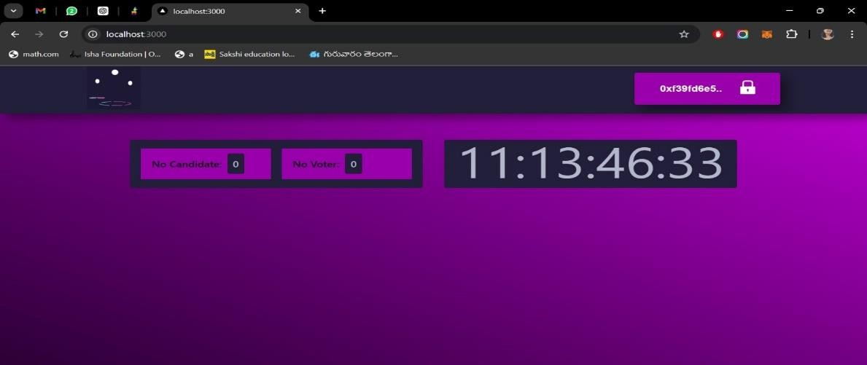
Fig: 5.1 home page

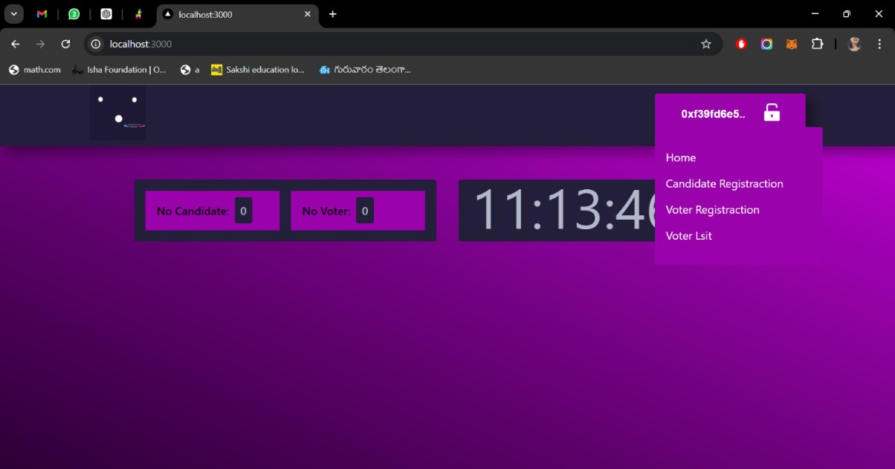
Fig: 5.2 home page 2

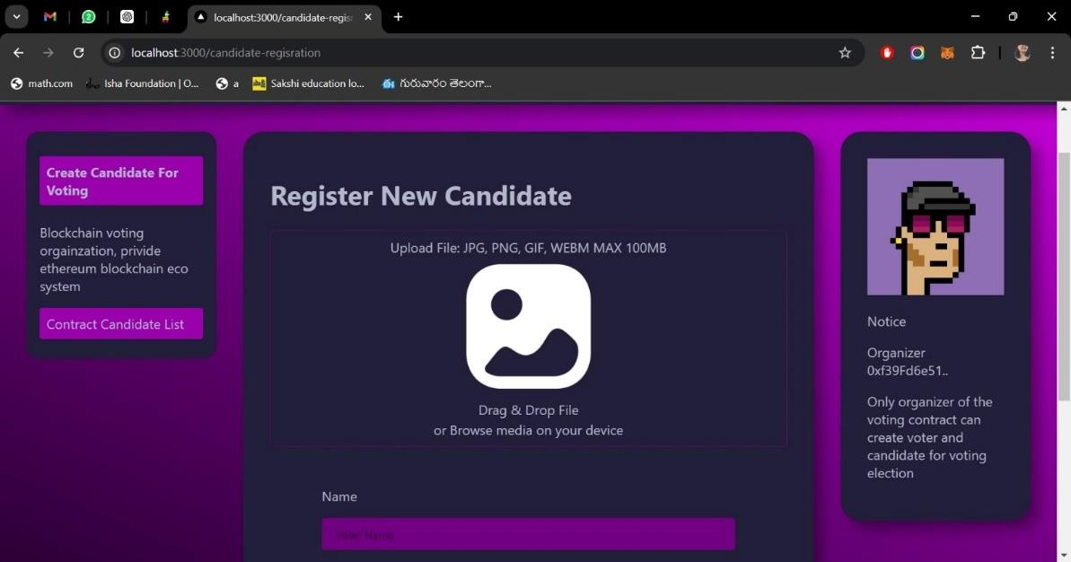

Fig:5.3 candidate registration 1

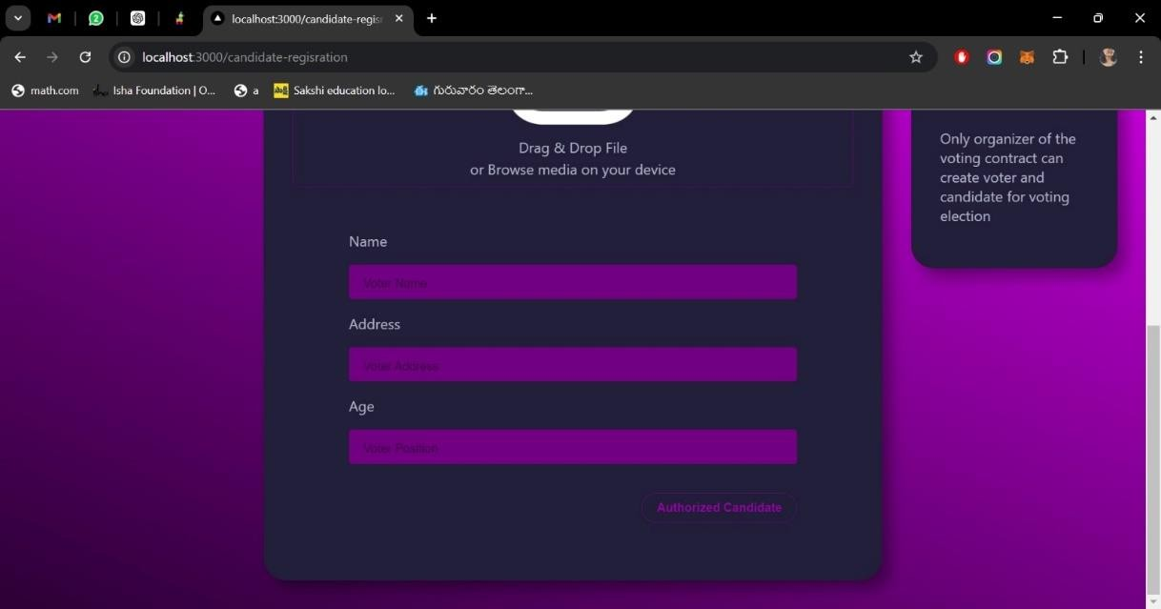

Fig:5.4 candidate registration 2

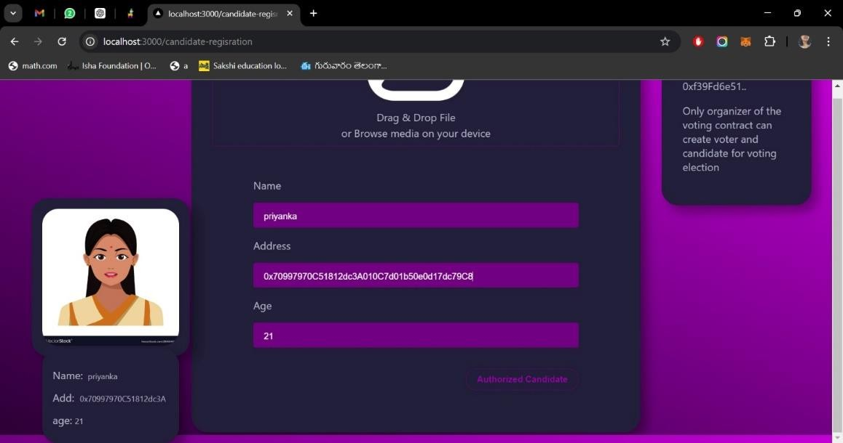

Fig 5.5 First candidate registration

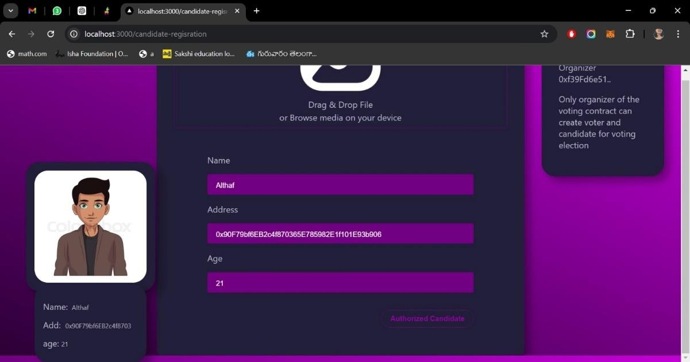

Fig 5.6 second candidate registration

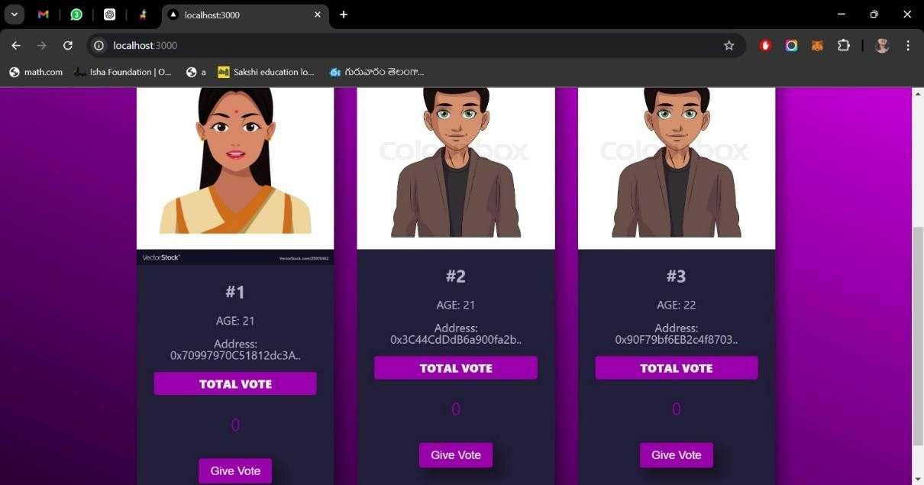
Fig 5.7 candidate list in home page

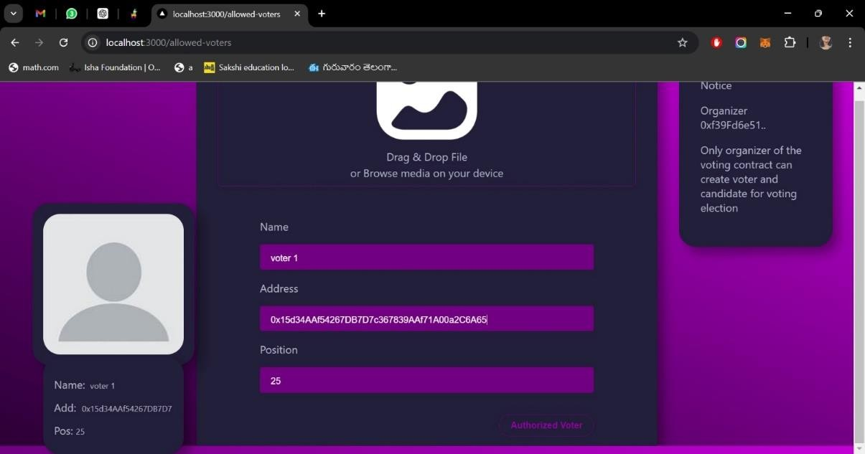

Fig 5.8 voter registration

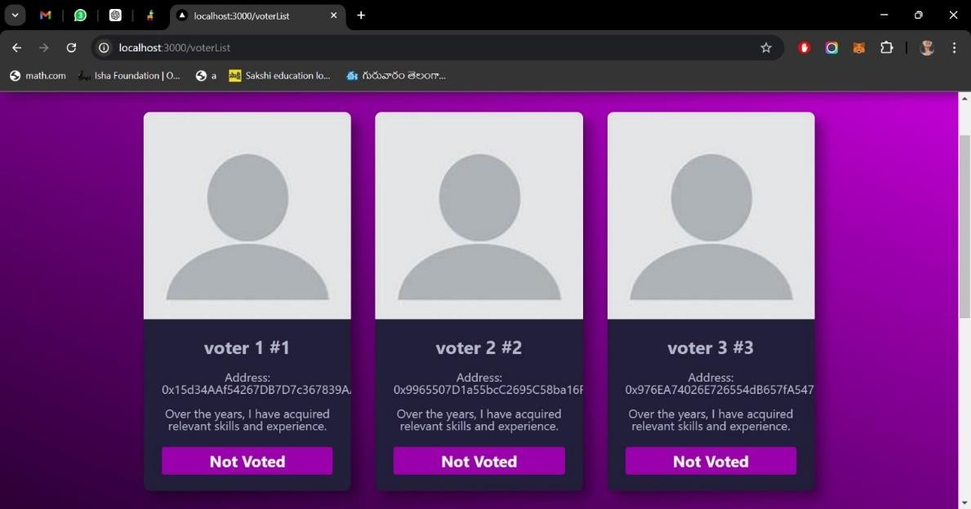
Fig 5.9 voter list in home page

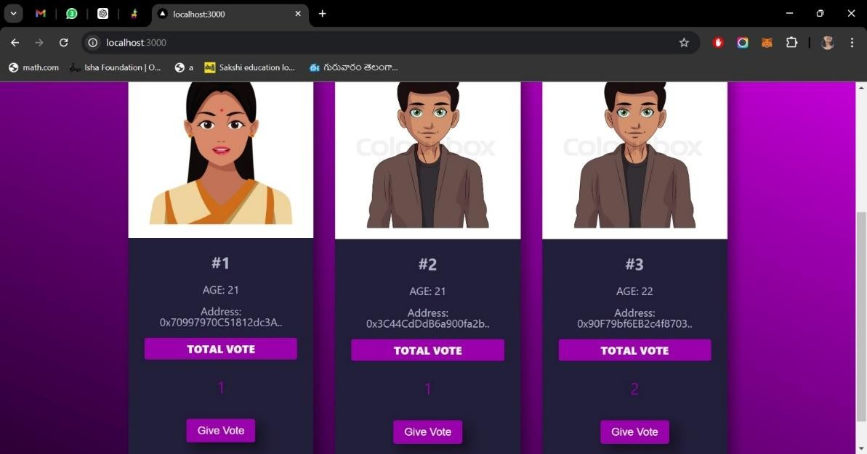
Fig 5.10 votes casted

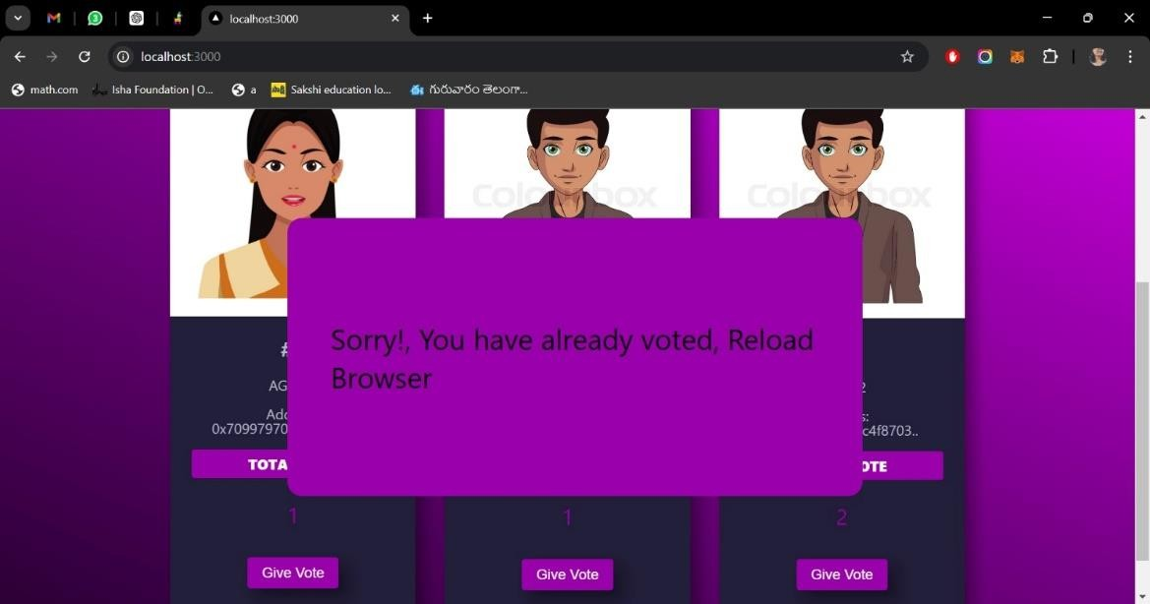
Fig 5.11 vote tampering

SYSTEM TESTING

INTRODUCTION TO TESTING
Software testing is a process, to evaluate the functionality of a software application with an intent to find whether the developed software met the specified requirements or not and to identify the defects to ensure that the product is defect free to produce a quality product.

Types Of Tests

Application Testing

It is defined as a software testing type, conducted through scripts with the motive of finding errors in software. It deals with tests for the entire application. It helps to enhance the quality of your applications while reducing costs, maximizing ROI, and saving development time.

System Testing

It is a level of testing that validates the complete and fully integrated software product. The purpose of a system test is to evaluate the end-to-end system specifications. Usually, the software is only one element of a larger computer-based system.

GUI Testing

GUI Testing is a software testing type that checks the Graphical User Interface of the Software. The purpose of Graphical User Interface (GUI) Testing is to ensure the functionalities of software application work as per specifications by checking screens and controls like menus, buttons, icons, etc.

Security Testing

Security Testing is a type of Software Testing that uncovers vulnerabilities of the system and determines that the data and resources of the system are protected from possible intruders. It ensures that the software system and application are free from any threats or risks that can cause a loss. Software Testing is a method to check whether the actual software product matches expected requirements and to ensure that software product is Defect free.

Test Cases
Test case writing is a major activity and considered as one of the most important parts of software testing. It is used by the testing team, development team as well as the management. If there is no documentation for an application, we can use the test case as a baseline document.
TABLE 6.1: TEST CASES For Online Voting System

Test Case ID | Case  Description | Test Steps | Expected Result | Pass or Fail
TC- 01 | User Login via MetaMask | - Open the voting platform | The website should be | pass
TC- 02 | Cast Vote  Successfully | 1. Select candidate 2. Click on "Cast Vote" 3. Confirm transaction via MetaMask | It displays Homepage, Admin, New voter signup, login successfully. | pass
TC- 03 | Voting Reattempt Prevention | - Login via MetaMask  - Attempt to vote again | User has already cast a vote | pass
TC- 04 | Vote Transaction Validity | 1. Cast a vote 2. Retrieve transaction details via  blockchain explore | Valid vote transaction on the blockchain | pass

Test Case ID | Case  Description | Test Steps | Expected Result | Pass or Fail
TC- 05 | Unauthorized Voting Attempt | 1. Access voting platform without  MetaMask 2.  Attempt to login or vote | User without MetaMask or not authorized to vote | pass
TC- 06 | MetaMask Transaction Denied | 1. Attempt to vote 2. Deny MetaMask transaction | User is logged in but denies the MetaMask  transaction | pass
TC- 07 | Blockchain Confirmation Delay | 1. Cast vote 2. MetaMask transaction is confirmed, but vote is not instantly reflected | User's vote takes time to confirm on the blockchain | pass
TC- 08 | Multiple Elections Participation | 1. Login via  MetaMask 2. Access  different elections 3. Cast vote in bot | User can participate in more than one election using the same account | pass

Test Case ID | Case  Description | Test Steps | Expected Result | Pass or Fail
TC- 09 | Election Results Verification | 1. Admin accesses result page 2. Retrieve results from blockchain | Election administrator checks results after voting  period ends | pass
TC- 10 | Election Rsults | 1. Admin accesses result page 2. Retrieve results from blockchain | Election administrator checks results after voting  period ends | pass

CONCLUSION

PROJECT CONCLUSION
The goal of this research is to analyze and evaluate current research on blockchain-based electronic voting systems. The article discusses recent electronic voting research using blockchain technology. The blockchain concept and its uses are presented first, followed by existing electronic voting systems. Then, a set of deficiencies in existing electronic voting systems are identified and addressed. The blockchain’s potential is fundamental to enhance electronic voting, current solutions for blockchain-based electronic voting, and possible research paths on blockchain-based electronic voting systems. Numerous experts believe that blockchain may be a good fit for a decentralized electronic voting system. Furthermore, all voters and impartial observers may see the voting records kept in these suggested systems. On the other hand, researchers discovered that most publications on blockchain-based electronic voting identified and addressed similar issues. There have been many study gaps in electronic voting that need to be addressed in future studies. Scalability attacks, lack of transparency, reliance on untrustworthy systems, and resistance to compulsion are all potential drawbacks that must be addressed.

FUTURE ENHANCEMENT
The online voting system using blockchain and MetaMask can be further enhanced by incorporating advanced cryptographic techniques and decentralized technologies. One potential enhancement is integrating Zero-Knowledge Proofs (e.g., zk-SNARKs) to ensure voter privacy and anonymity, enabling users to prove they voted without revealing their identity or the contents of their vote. This would address privacy concerns in a public ledger system. Additionally, the system could incorporate decentralized storage solutions like IPFS (InterPlanetary File System) for storing voter information and election data, ensuring data integrity and availability without relying on a centralized server.

REFERENCES

Journals

- Online Voting System Using Blockchain, 2022 International Conference on Electronics and Renewable Systems by S. Drakshayani, U. Vijayalakshmi, S.R.Sri, A.Srivani and A.Vyshnavi, 2022, pp. 886- 891A.
- De-Centralized Voting System using Blockchain, by A. Jangada, N. Dadlani, S. Raina, V. Sooraj and A. R. Buchade 2022 IEEE International Conference on Blockchain and Distributed Systems Security,2022, pp. 1-5.
- Block voting: An Online Voting System Using Block Chain, by D.K and C.K 2022 International Conference on Innovative Trends in Information Technology, 2022.
- E. Androulaki, A. Barger, V. Bortnikov, C. Cachin, K. Christidis, A. De Caro, D. Enyeart, C. Ferris, G. Laventman, Y. Manevich et al.. "Hyperledger fabric: a distributed operating system for permissioned blockchain," in Proceedings of the thirteenth EuroSys conference, 2018, pp. 1-15.
- Blockchain-Based Online E-voting System," 2023 by Y. A. F. Ali. Q. T. M. Ahmed,
M. A. M. Diab, M. A. E. Sayed, M. K. Abd Elaziz and B. W. Aboshosha, International Conference on Smart Computing and Application (ICSCA), Hail, Saudi Arabia, 2023,
pp. 1-8 International Journal of Engineering Research & Technology (LJERT)

WEB LINKS:

    - https://docs.metamask.io/guide/
    - https://docs.soliditylang.org/en/v0.8.0/
    - https://trufflesuite.com/
    - https://remix.ethereum.org/

TEXT BOOK

    - Mastering Ethereum: Building Smart Contracts and DApps
    - Blockchain Basics: A Non-Technical Introduction in 25 Steps
    - Blockchain Technology: Concepts and Applications

